Project Report

# Title: Student Registration and CGPA Calculation Website

## 1. Introduction

This project is a comprehensive web-based application developed to simplify and automate the process of student registration and CGPA (Cumulative Grade Point Average) calculation. The system enables students to register by entering their personal and academic details, including name, student ID, date of birth, email, password, gender, and department and view their inputed information. Teachers also can register student and input their subject-wise marks, and the system calculates their CGPA instantly based on a predefined grading formula. This reduces the need for manual calculations and helps students track their academic performance more efficiently. The application is built using Python along with the Flask framework for handling server-side operations. HTML and CSS are used to design a clean and responsive user interface, ensuring an easy and user-friendly experience. For data storage and management, XAMPP is used, which provides a local server environment including Apache and MySQL, allowing efficient handling of user data in a structured database. Overall, this project integrates frontend design, backend logic, and database connectivity to create a useful academic tool for both students and educational institutions.

## 2. Objective

## The main objective of this project is to develop an efficient and user-friendly web platform that simplifies the student registration process and automates CGPA (Cumulative Grade Point Average) calculation. Traditionally, students and educational staff spend a significant amount of time manually registering student details and calculating academic results, which is both time-consuming and error-prone. This project aims to reduce that workload by providing a digital solution where students can easily input their personal and academic information, and the system will handle data storage .Also CGPA computation from given subjects marks automatically provided by admins or teachers. Admins or teachers can delete and edit info from MySQL database .By doing so, it enhances accuracy, saves time, and allows students to monitor their academic progress with minimal effort.

## 3. Tools and Technologies Used

- Python  
- Flask (Python web framework)  
- HTML and CSS (Frontend design)  
- XAMPP (Apache server and MySQL database)

## 4. Target Users

## The primary users of this project are students from schools, colleges, and universities who need a simple and effective way to register themselves .Also useful for admins or teacher to calculate CGPA of student for different semester, edit and delete information from database. In addition the application can also be beneficial for educational institutions, such as schools, colleges, and training centers, to manage and store student information in an organized manner. Academic staff, including teachers and advisors, can use the platform to quickly access and review student records, analyze performance trends, and provide guidance based on accurate data. The system is designed to be accessible and useful for a wide range of academic users at different levels.

## 5. Social and Economic Value

This project holds significant social value by encouraging digital literacy among students and educators, especially in educational environments where digital tools are still underutilized. By offering a simple and accessible platform, it empowers students to independently manage their academic data, stay organized, and become more aware of their academic progress. The system also promotes environmentally responsible practices by reducing the need for paper-based documentation and minimizing manual errors in data entry and calculation. From an economic perspective, the project has strong potential for scalability. Educational institutions can adopt this system to streamline their administrative processes, reduce operational costs, and enhance overall efficiency. By minimizing time spent on repetitive tasks such as data entry and CGPA calculation, institutions can focus more on academic development and student support.

## 6. Project Features

- Student Registration Form: Collects essential student details such as name, ID, date of birth, email, gender, and department.  
- Database Integration: Stores student data securely in a database using XAMPP (MySQL).  
- Data Display: Displays the entered registration data for user confirmation.  
- CGPA Calculation: Only teachers or admins can give input subject-wise marks. Students or any external user will not be able to input marks. Access will be denied for them because authentication is used here. After clicking on the calculation CGPA button of the registration form an interface will open for the user where he will be asked to input the password. If he inputs result as the password, only then will the user be able to input the subject-wise mark.  
- Result Page: Shows the final CGPA on a separate page in a clean and readable format.

## 7. System Description

The website begins with a user-friendly registration form where students are required to provide their essential personal and academic details, including full name, student ID, date of birth, email address, password, gender, and department. This information is validated and then stored securely in the backend database using XAMPP (MySQL). Upon successful submission, the system displays the entered information on a confirmation page, allowing the student to verify that their registration was successful.

Admin or teacher can register students. Along with this, they can input the marks of 5 subjects to calculate the student's CGPA. Depending on those five subjects, the CGPA and all its previous CGPA average will be calculated and shown immediately. The system processes these inputs using a predefined algorithm to calculate the CGPA accurately. No one other than the admin or teacher will be able to take advantage of this CGPA calculation feature because access to this section has been blocked for other users. When a user clicks on the calculator button in the registration form, an interface will appear in front of him and he will be asked to enter a password. If he inputs "result" as the password, then only he will be able to use the CGPA calculation feature. Finally, the computed CGPA is displayed on a result page in a clear and structured format. This workflow ensures a smooth and automated process from data collection to academic performance evaluation, reducing human effort and errors.

**8. Project Showcase:**

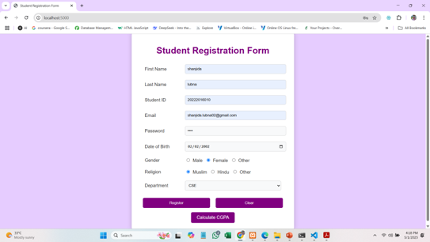

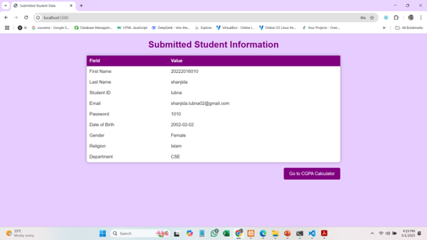

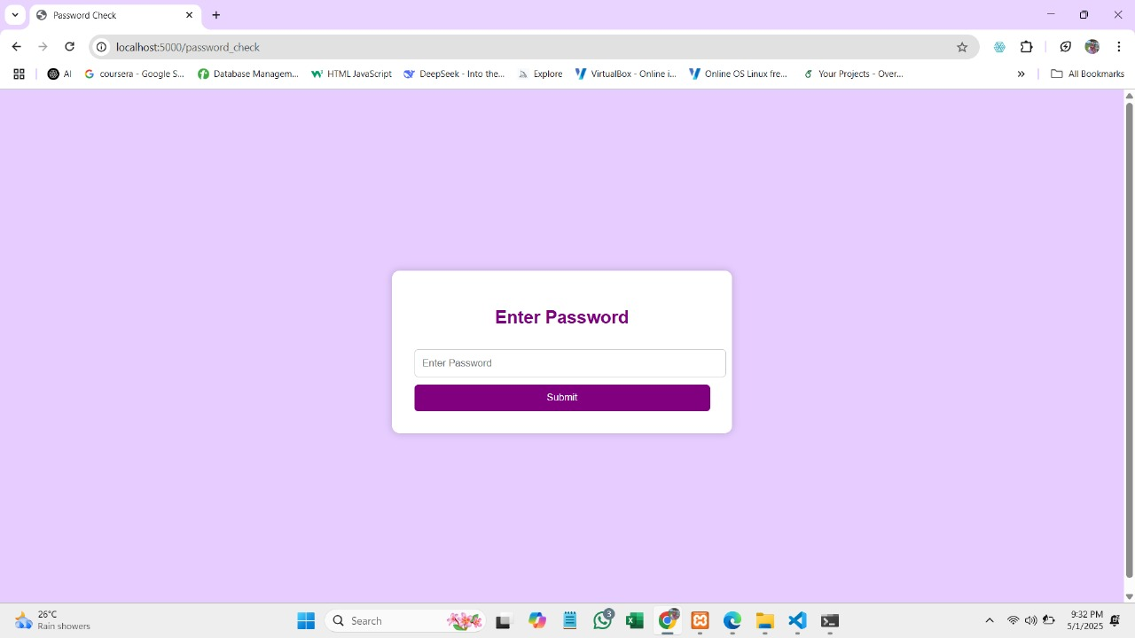

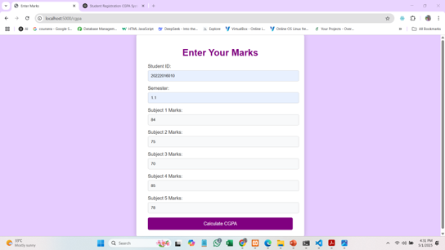

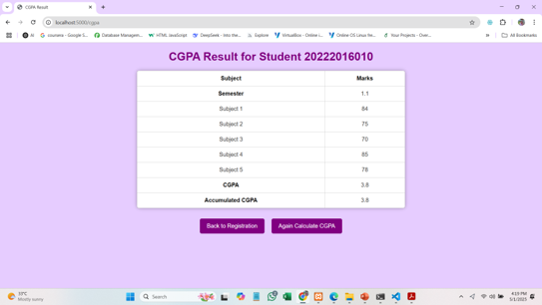

**Fig:** Project Diagram

## Database overview :

## 

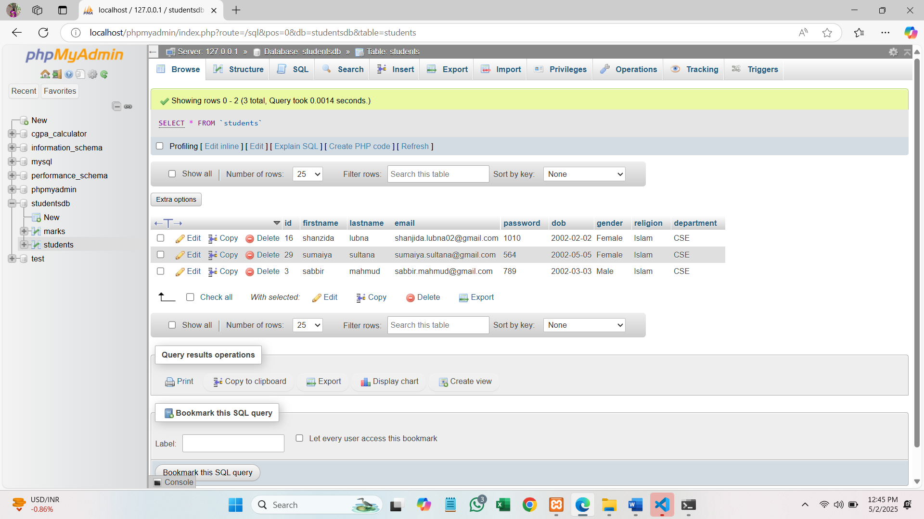

## 9. working Process

Step 1: Student fills in the registration form with personal details.  
Step 2: Data is stored in the database and shown back for confirmation.  
Step 3: Admins or teachers enters marks obtained in various subjects.  
Step 4: The system calculates CGPA using a predefined formula.  
Step 5: CGPA is displayed on a result page with a clean layout.

## 10. Future Scope

In the future, the website can be significantly enhanced by adding a secure login system, enabling students to create personal accounts where they can easily save and view their CGPA anytime. This would allow users to access their academic progress from any device, ensuring convenience and personalized data tracking. Additionally, optimizing the site for mobile devices would improve its accessibility, enabling students to check their CGPA and progress on-the-go, no matter where they are. The platform could also support various grading systems, allowing students from different educational institutions to input and track their academic performance according to their respective grading scales, whether it be GPA, percentage, or CGPA. A CGPA prediction feature could be introduced, enabling students to estimate their future CGPA based on current academic data, which would help them plan their courses and workload more effectively. Furthermore, providing an option to download detailed academic reports in formats like PDF or Excel would allow students to keep records of their progress for personal use or administrative purposes. Adding interactive graphs to display academic trends, such as semester-wise CGPA or grades across subjects, would provide a more visual and engaging way for students to assess their performance. A personalized student dashboard could be created, offering a consolidated view of current CGPA, predicted CGPA, and academic progress, encouraging students to stay on top of their studies. Secure data export options would ensure that students can safely download and share their academic records when needed. With a modern and user-friendly interface, along with possible integration with institutional systems for automatic grade syncing, the platform could become a vital tool for students to manage their education, make informed decisions, and track their academic journey with ease.

**11. Conclusion**

This project offers a straightforward and intuitive solution for student registration and CGPA calculation, making it easier for students to manage and track their academic performance. It provides a streamlined way for educational institutions to handle student data, improving overall efficiency in record-keeping and academic monitoring. By simplifying the process of registering students and calculating CGPA, the platform reduces administrative workload and enhances data accuracy. As the project evolves, it holds the potential to expand into a comprehensive academic management system, offering a wide range of features for both students and institutions.